Youth Emergency Services
Host Home Handbook

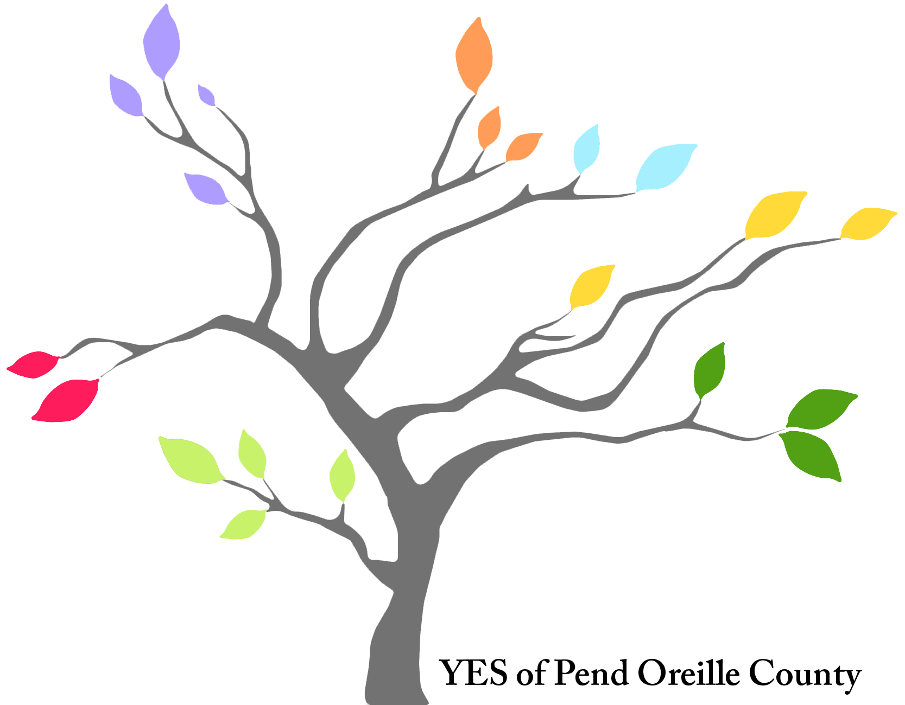
What is a Host Home?

A Safe Intervention
Short-term host homes are an intervention for youth who are currently experiencing homelessness for any variety of reasons, including but not limited to family conflict, poverty, gender identity and sexual orientation. The goal of short-term host homes is to provide a safe, temporary, welcoming space for up to six months where the young person has time to repair their relationships with self-identified family or make decisions about other housing options with the support of a caring housing case manager. Successful implementations of short-term host homes have generally been volunteer-based programs, with stays lasting from three to six months; however, other successful implementations addressing community needs have existed in the short-term housing system. Providing short-term host homes is a cost-effective and successful model for preventing youth homelessness in a wide range of cases.

Host Home Program Values
Avenues for Homeless Youth shares the following values with potential hosts, youth and other stakeholders in their program:

- Articulating the program’s core values sets the foundation for an equitable and youth-driven host home program
- We seek to recognize and challenge systems of power that perpetuate barriers and injustice in young people’s lives (such as racism and classism), and we are aware that not all youth get the same results through the same hard work under these systems
- We approach youth work through a lens of social justice and youth empowerment
- We value diversity in all its forms
- We believe in supporting youth regardless of their racial or ethnic identity, religious affiliations, or lack thereof, gender identity or sexual orientation
We acknowledge that a youth’s sexual and gender identity may change throughout their adolescence; a youth who identifies as straight or a specific gender when they are referred into the program may begin to question their sexual orientation or gender identity at any time
- We believe in trauma-informed and harm reduction strategies that affirm youths’
strengths and their own agency
- We believe in leading through example and fostering shared leadership
- We understand that all youth will sometimes make choices we don’t agree with, and we acknowledge the youth’s right to make those choices for themselves
- We understand that choices youth make about sexual activity or other behaviors might be different from those we might wish or expect for our own children and we do not fill a parental role for the youth in the program
- We believe that youth benefit from living with adult allies who are aware of the
inherent power dynamics of the host home model and strive to minimize misuse of power
Point Source Youth, Host Home Handbook Version 2.0

All applicants must:
- Have an extra bedroom (providing privacy) for the youth
- Be at least 25 years old
- Have lived in the state of WA for at least a year
- Complete the application form, providing relevant information
- Have renter/homeowner’s insurance, providing a file copy if requested
- Provide three references
- Authorize and pass background checks which include:
  - Public Records (e.g. arrest reports)
  - IntelliCorp Records, Inc.
- Complete necessary interview
- Complete the initial training session
The above criteria need to be successfully completed in order for an applicant to be qualified as a host. Participation of applicants can be terminated at any point in the screening process if the program manager believes they are not qualified/ready to be a host volunteer. Applicants need to demonstrate a strong commitment to work with a youth to build a healthy and trusting relationship, an ability to provide a supportive environment and consistently demonstrate skills necessary to make that happen.

Hosts are encouraged to think about key issues and questions that will prepare them to create a safe, welcoming space for youth.
What are the ‘rules’ of your home?
Think about sharing your living space with a youth you don’t know very well. Think about the rules and expectations that will be important for that person to know (e.g. no smoking in the house). The youth moving in will also have rules/expectations of their own (e.g. knock before you enter). Most importantly, what are your non-negotiables?
What are your expectations of the youth while they live with you?
The Host Home Program is an opportunity for the youth to live in a safer and healthier environment while they work on self-determined goals, which they develop with the support of their case manager. As your relationship with a youth grows and deepens, so might your involvement re: goals/things they want to do. This is really up to the youth to decide. Note: Hosts tend to almost never feel like the youth is working hard enough/fast enough/genuinely enough on said goals, regardless of how open-minded they are. The program will support and challenge you in managing your own expectations and dealing with frustrations that may arise.
What is your financial commitment to this youth?
YES will assist the young person with food but you will be responsible for providing additional food for meals for the duration of their stay. You should expect your utility and groceries bills to go up. Aside from food and a supportive home, you will not be responsible for other expenses. The case manager and program manager can work with you on setting appropriate boundaries re: expenses.
Is your living space ready for a young person?
The youth must have their own room or private space. That room/space should be clean when the youth moves in. Make sure that your smoke alarms work and that you
have accessible fire extinguishers. If you have alcohol in the house, it should be kept in a safe place where the youth is less likely to have access to it.
Have you ever lived with a queer and/or transgender youth?
We encourage you to get acquainted with LGBTQ+ youth issues and explore your own understanding about sexual orientation and gender identity and learn to be able to talk about those issues. Even many people who identify as gay, lesbian or bisexual don’t necessarily have much awareness about transgender and gender-queer identities.
Have you ever explored your personal biases?
Bias is defined as disproportionate weight in favor of or against an idea or thing, usually in a way that is inaccurate, closed-minded, prejudicial, or unfair. Biases can be innate or learned. People may develop biases for or against an individual, a group, or a belief. A few examples of personal biases can include racial bias, gender bias, and disability bias.
We all hold our own subjective world views and are influenced and shaped by our experiences, beliefs, values, education, family, friends, peers and others. Being aware of one's biases is vital to personal well-being.
Are you willing to put in some time to create a nurturing relationship with a youth?
Developing a trusting relationship with a youth may take some time and hard work. This may require you to be an active participant in that young person’s life (e.g. driving them places, helping with schoolwork, meeting with case manager). According to some hosts, this often feels like “parenting.”
Are you capable of living with a youth who may be working through difficult issues?
You need to be conscious that the young people who participate in the Host Home program will likely have experienced trauma. These issues will also be discussed during the training. Your role as a host is not to ‘rescue’ youth, but to be an adult ally.

Writing the unwritten— Speaking the unspoken
Here is an exercise from Avenues for Homeless Youth to help hosts prepare for welcoming youth into their home!
What are the “invisible rules” for your household related to the following? (please spend a bit of time writing your thoughts down after each and then we will share/ discuss)
Food:
Money:
Sex:
Arguing:
Drugs/alcohol:
Cleanliness:
Personal hygiene:
Religion/Spirituality:
Honesty:
Work ethic:
Politics:
Authority:
Visitors/guests:
Community:
Communication:
Decision-making:
Privacy:

What are the 'bottom lines' you hold?

Creative Assignment  (Required)

Please write a letter talking about yourself, your family and community, some of your life experiences, strengths, etc. Write it with a young person in mind as the reader. The purpose of this letter is for them to get to know you a bit, find out why you want to be a host, and see if you might be someone they would like to live with. In addition, this letter will help the Host Home Program Coordinator have a better sense of you as a potential volunteer host. Poems, drawings, and other way of expression are welcomed. You can do an audio recording or a video, too.

Trainings
YES will provide Host Home families with in-person and on-line trainings in the following areas. As the program grows, more trainings will be possible. All trainings are free and those marked with an asterisk (*) are mandatory.

Personal Biases-
To have personal biases is to be human. We all hold our own subjective world views and are influenced and shaped by our experiences, beliefs, values, education, family, friends, peers and others. Being aware of one's biases is vital to personal well-being.

When you realize what your personal triggers are—triggers that contribute to the creation of personal biases—you can actively manage, mitigate or avoid them. The ultimate goal is to achieve happiness through building and maintaining healthy relationships.

https://www.learningforjustice.org/professional-development/test-yourself-for- hidden-bias

*Cultural Competency-Cultural competence is important because without it, our opportunity to build those relationships is impossible. Instead, we'll co-exist with people we don't understand, thereby creating a higher risk for misunderstandings, hurt feelings, and bias—things that can all be avoided.
https://cultureplusconsulting.com/2018/08/16/a-ha-activities-for-unconscious-bias- training/

http://www.aldenhabacon.com/sample-full-day-diversity-inclusion-training-2020

Cultural competence comprises four components:
- Awareness of one's own cultural worldview,
- Attitude towards cultural differences,
- Knowledge of different cultural practices and world views, and
- cross-cultural skills.

LGBTQ+ 101 - Affirmative Care -
Who: The Center for Children & Youth Justice (CCYJ) is creating better lives
for generations of children and youth through reform of child welfare, juvenile justice, and related systems of care. At CCYJ, the eQuality Project works to create safer and more affirming systems for lesbian, gay, bisexual, transgender, queer, and questioning (LGBTQ+) youth.

What: CCYJ is partnering with juvenile courts, homeless service providers,
and Department of Children, Youth, and Families (DCYF) across Washington to implement the Protocol for Safe & Affirming Care, a guide for professionals, volunteers, and caregivers on creating safer and more affirming systems of care for LGBTQ+ youth.

Why: CCYJ’s eQuality Project aims create safer and more affirming systems for not only LGBTQ+ youth–but all youth–in child welfare, juvenile justice, and related systems of care. Through implementation of the Protocol, eQuality also aims to prevent and intervene with LGBTQ+ youth homelessness. Resources can be found here: https://ccyj.org/isac/

Assertive Communication - Assertiveness is a communication style in which a person stands up for their own needs and beliefs, while also respecting the needs of others.
Assertive communication is defined by mutual respect, diplomacy, and directness.
https://www.therapistaid.com/therapy-worksheet/assertive-communication

Trauma and Resiliency - Trauma Informed Care - Participants learn six principles that guide a trauma-informed approach, including:
Safety
Trustworthiness & transparency Peer support
Collaboration & mutuality Empowerment & choice
Cultural, historical & gender issues

https://traumainformedoregon.org/resources/trauma-informed-care-principles/

Adopting a trauma-informed approach is not accomplished through any single particular technique or checklist. It requires constant attention, caring awareness, sensitivity, and possibly a cultural change at a personal and organizational level.

Power and Privilege - Inequity secondary to race, gender identity, sexuality, gender, BIPOC, immigrant status, homelessness

Adultism- “Everyone benefits when youth and adults work together, but there are unique challenges to learning how to work together as equals.” John Bell, YouthBuild, USA
https://www.canr.msu.edu/news/understanding_adultism_creating_positive_youth- adult_partnerships

When we address the unequal balance of power between youth and adults and learn how to work together in a partnership, we can help create a stronger relationship based on respect, mutual friendship and sharing. Research on positive youth development tells us that adults should welcome and value the voices of young people as resources in their communities. By being aware of the obstacles, you can try to avoid them and stay on track to treating young people as true partners. When we see young people as partners, they develop better self-esteem, increase problem-solving skills and are more likely to be seen as leaders in their community.

Mandatory Reporting - State of WA requirements to report suspected abuse or neglect of a minor, or vulnerable adult.
https://www.dcyf.wa.gov/safety/mandated-reporter

